CHC32015M Certificate III in Community Services
Release 3

CHC32015M Certificate III in Community Services

Modification History
Release | Comments
Release 1 | This version released with CHC Community Services Training Package Version 11.  CHC32015M Certificate III in Community Services supersedes and is not equivalent to CHC32015 Certificate III in Community Services.  Major changes to core and elective units of competency.

Qualification code  DRAFT  Mandatory field | CHC32015M
Qualification title  Mandatory field | Certificate III in Community Services
Qualification description  Mandatory field | This qualification prepares individuals for entry-level community services roles, enabling them to provide person-centred support to individuals and/or groups. Work is performed under direct or indirect supervision, with individuals taking some responsibility for their own outputs.  The skills in this qualification must be applied in accordance with Commonwealth and State or Territory legislation, Australian standards and industry codes of practice.
Foundation skills outcomes  Mandatory field | The foundation skills outcomes implicit in this qualification are outlined in the below bar chart.  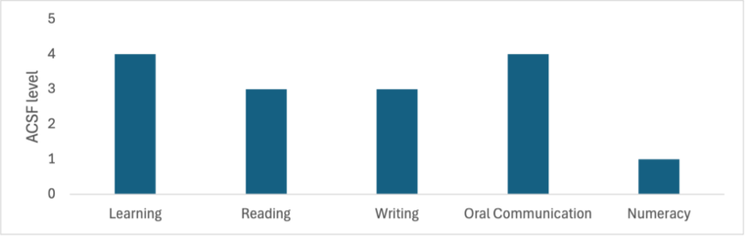  Note: Some elective units require higher foundation skills levels. Please refer to the Companion Volume Implementation Guide for more information.
Entry requirements  Optional field | N/A
Qualification mapping information  Mandatory field | CHC32015M Certificate III in Community Services supersedes and is not equivalent to CHC32015 Certificate III in Community Services
Packaging Rules  DRAFT | Total number of units = 12  - 8 core units  - 4 elective units, consisting of:  - at least 2 units from the electives listed below  - up to 2 units from the electives listed below, any endorsed Training Packages or accredited courses – these units must be relevant to the work outcome  All electives chosen must contribute to a valid, industry-supported vocational outcome.  * Indicates proposed draft title – subject to further consultation  M indicates proposed major changes  X indicates cross sector  Core Units  CHCCCS016M Respond to client needs  CHCCOM005M Communicate and work in health or community services  CHCDIV001M Work with diverse people  CHCDIV002M *Support culturally responsive practices with Aboriginal and/or Torres Strait Islander peoples  CHCLEG001 Work legally and ethically  CHCMHS007 Work effectively in trauma-informed care  HLTWHS002 Follow safe work practices for direct client care  HLTWHS006 Manage personal stressors in the work environment  Elective units  BSBINS302 Organise workplace information  BSBLDR301 Support effective workplace relationships  BSBOPS101 Use business resources  BSBPEF301 Organise personal work priorities  BSBSTR301 Contribute to continuous improvement  BSBTEC201 Use business software applications  BSBTEC203 DRAFT Research using the internet  BSBWRT311 Write simple documents  CHCADV001 Facilitate the interests and rights of clients  CHCAOD001 Work in an alcohol and drugs context  CHCAOD002M *Work with people who are intoxicated  CHCAOD003 Provide needle and syringe services  CHCCCS003M *Increase the safety of people at risk of suicide  CHCCCS005M Conduct individual assessments  CHCCCS009M Facilitate responsible behaviour  CHCCCS017 Provide loss and grief support  CHCCCS019 Recognise and respond to crisis situations  CHCCCS026 Transport individuals  CHCCCS028M *Provide person-centred support to people in crisis  CHCCCS031 Provide individualised support  CHCCCS033 Identify and report abuse  CHCCCS038 Facilitate the empowerment of people receiving support  CHCCCS040 Support independence and wellbeing  CHCCDE017 Support collaborative planning processes  CHCCDE019 Work within a community development framework  CHCCDE020 Implement participation and engagement strategies  CHCCOM001M Provide first point of contact  CHCDEV004M Confirm developmental status  CHCDFV001M *Identify and respond to family, domestic and/or sexual violence  CHCDIS011 Contribute to ongoing skills development using a strengths-based approach  CHCDIS012 Support community participation and social inclusion  CHCDIS020 Work effectively in disability support  CHCDIV002M *Support culturally responsive practices with Aboriginal and/or Torres Strait Islander peoples  CHCEDU003 Provide sexual and reproductive health information to clients  CHCEDU005 Work with clients to identify financial literacy education needs  CHCEDU009 DRAFT Provide parenting, health and well-being education  CHCGMB001 Assess the needs of clients with problem gambling issues  CHCGRP001 Support group activities  CHCGRP003 Plan, facilitate and review psycho-educational groups  CHCMHS001M *Work with people with mental health challenges  CHCPRP001 Develop and maintain networks and collaborative partnerships  CHCPRT025 Identify and report children and young people at risk  CHCSET003 Work with forced migrants  CHCSET004 Undertake bicultural work with forced migrants in Australia  CHCSOH013 Work with people experiencing or at risk of homelessness  CHCVOL001 Be an effective volunteer  CHCYTH013 Engage respectfully with young people  CHCYTH015 Support young people to create opportunities in their lives  FSKDIG003 Use digital technology for non-routine workplace tasks  FSKLRG006 Participate in work placement  HLTAAP001 Recognise healthy body systems  HLTAID011 Provide first aid  HLTHPS006 Assist clients with medication  PSPLAN003 Source information on Deaf culture, and communicate according to Deaf protocol  SITXFSA006 Participate in safe food handling practices  TLIC0031 Apply low risk car driving behaviours

DRAFT

